
Allan Stewart Konigsberg, a.k.a. Woody Allen, was born in the Bronx on December 1, 1935. At the age of three he got hooked on movies when his mother took him to see Snow White. From that day the movie theaters became his second home. Growing up he had a hard time in school as he was very intelligent but didn’t really enjoy classes. At 15 he started writing jokes for news papers. At this point he took on the name Woody Allen because he didn’t want classmates to know he was writing the jokes. He went on to attend film school at NYU but was thrown out after the first year because he did not attend classes and the professors didn’t like his comedic papers. After that point he started working on his comedy material, and didn’t get into film making until 1964 when he was hired to write a screen play. ⁽¹⁾

Many of Woody Allen’s films have some reference to art cinema films. His biggest influence in film making was Swedish director Ingmar Bergman. In 1988, Allen was quoted as saying that Bergman was "probably the greatest film artist, all things considered, since the invention of the motion picture camera". ⁽²⁾ Bergman’s films and directing style are seen through nearly all of Allen’s films.

Examples of Movies with Bergman’s Art Cinema Influence:
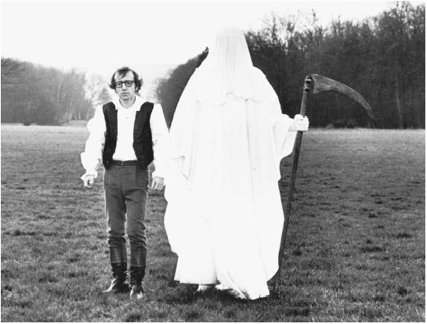
Love and Death (1975) is Allen’s first film to obviously mimic Bergman’s films. In the film Allen uses a Grim reaper character like that in Bergman’s The Seventh Seal (1957); however, Allen’s Grim reaper is draped in white as opposed to Bergman’s black draped reaper. Allen’s movie is set in the Napoleonic era and is a satire of Russian literature (Tolstoy, Dostoyevsky, and the films of Eisenstein). The intense overlapping close-ups are taken from PERSONA (1966). Bergman’s existentialism is felt in the monologue from Diane Keaton’s character:
"To love is to suffer. To avoid suffering one must not love. But then one suffers from not loving. Therefore, to love is to suffer; not to love is to suffer; to suffer is to suffer. To be happy is to love. To be happy, then, is to suffer, but suffering makes one unhappy. Therefore, to be unhappy, one must love or love to suffer or suffer from too much happiness. I hope you're getting this down."
Seen in this clip http://www.youtube.com/watch?v=GSzLZbXBMsg

Annie Hall (1977) is Allen's most popular film commercially and winner of the Academy Award for best picture. This film has fewer references to Bergman’s films but there are a few returns to childhood memories like that in Wild strawberries, and also close-ups like that of Persona. It is also interesting to note that in Annie Hall the character Alvy (Allen) refuses to miss the beginning of a film because of Annie's (Diane Keaton) tardiness and that film was Bergman's Face to Face (1976).
Trailer: http://www.youtube.com/watch?v=TBzHphcc2Jw

Interiors (1978) was Woody Allen’s first drama. It is evident throughout the movie. that Allen drew greatly from Bergman’s films. The term “Bergmanesque” was coined by Richard Schickel (TIME Magazine) for this film. Vincent Canby of the New York Times wrote:
“It's almost as if Mr. Allen had set out to make someone else's movie, say a film in the manner of Mr. Bergman, without having any grasp of the material, or first-hand, gut feelings about the characters. They seem like other people's characters, known only through other people's art.”

There are many close-ups and shots of contemplative looks out of windows which directly follow Bergman’s ideas.

Trailer: http://www.youtube.com/watch?v=lhphrzgPpaE

There are many more examples of Art cinema’s especially Bergman’s influence on Woody Allen’s films. And Allen continues to praise the work of Bergman. In 2007, when Ingmar Bergman passed away Woody Allen was approached by many media outlets for comments because Allen is such a vocal fan of the celebrated art cinema director. There are many interviews from Allen and articles written by Allen about Bergman including the following links:

New York Times article = “The Man Who Asked Hard Questions” http://www.nytimes.com/2007/08/12/movies/12alle.html

Time Magazine Interview with Woody Allen about Ingmar Bergman by Richard Corliss
http://www.time.com/time/arts/article/0,8599,1648917,00.html

Video clips Interview of Woody Allen about Ingmar Bergman
http://philosophyoffilm.blogspot.com/2009/04/woody-allen-on-ingmar-bergman.html

References:

(1) Benediktsson, Johannes. Woodyallen.com. 2002-2004. 17 April 2009.
< http://www.woodyallen.com/>

(2) Johnson, Daniel Cook. “ Ingmar Bergman – The Woody Allen Angle”. Film Babble
Blog. 30 July 2007. 17 April 2009. <
http://filmbabble.blogspot.com/2007/07/ingmar-bergman-woody-allen-
angle.html>

